|  |  |
| --- | --- |
| **Topic** | Hazelcast |
| **Document Name** | HAZELCAST-EX-02 |
|  |  |

|  |  |  |  |
| --- | --- | --- | --- |
| **Document Difficulty Level** | | | |
| **Beginner** | **Junior** | **Senior** | **Expert** |
| □ | ■ | □ | □ |

# Document History

|  |  |  |  |
| --- | --- | --- | --- |
| Date | Author | Ver | Comments |
| 05.03.2025 | Mennan Tekbir | 1.0 | Initial Draft |
| 05.03.2025 | Mehmet Erdem Önal | 1.1 | Revisions |

# Hazelcast

## Exercise HAZELCAST-EX-02:

**Definiton:** Please pull & run hazelcast and man-center conatiners in your local machine. You may use the following Docker commands:

docker pull hazelcast/hazelcast:latest

docker run hazelcast/hazelcast:latest

docker pull hazelcast/management-center:latest

docker run --rm -p 8080:8080 hazelcast/management-center:latest

**Docker Hub Repo for Hazelcast:** <https://hub.docker.com/r/hazelcast/hazelcast>

**Docker Hub Repo for Hazelcast Management Center:** <https://hub.docker.com/r/hazelcast/management-center>

Please provide screenshots to show your work once the installation is complete.

## HAZELCAST -EX-02 Solution:

**Your Answer:**

Lokale docker kurduktan sonra hazelcast node pull edip runladıktan sonra hazelcast management center kurulumu yapılmıştır sonrasında cluster a bağlanılmıştır

metin, ekran görüntüsü, yazılım içeren bir resim

Yapay zeka tarafından oluşturulmuş içerik yanlış olabilir.

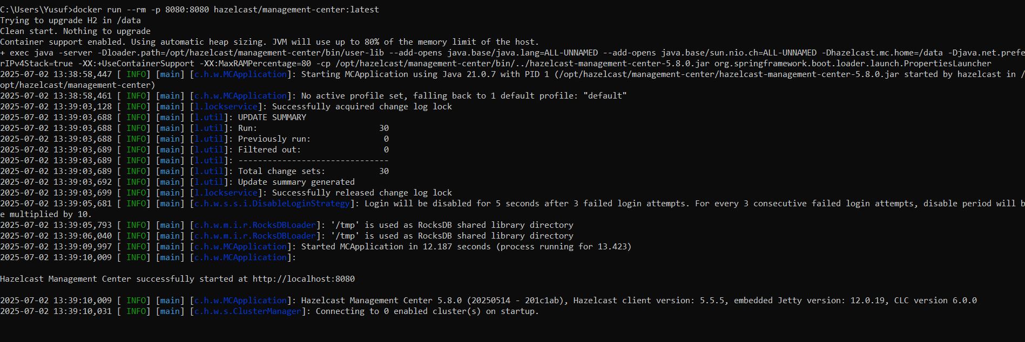

metin, ekran görüntüsü, yazılım, bilgisayar simgesi içeren bir resim

Yapay zeka tarafından oluşturulmuş içerik yanlış olabilir.